BookMind – Design Document
Course: BIL 481 – Programming Assignment 2
Project Title: BookMind – AI-Based Personalized Book Recommendation System
Team Name: VAREON
Contributors (Alphabetical):
- İclal Suzan
- Melih Rıza Koç
- Samet Emre Demir

Table of Contents
- System Overview
1.1 Brief Project Description
1.2 System Architecture
1.3 Technology Stack
- Implementation Details
2.1 Codebase Structure
2.2 Key Implementations
2.3 Component Interfaces
2.4 Visual Interfaces
- Use Case Support in Design
3.1 Selected Use Cases
3.2 Use Case 1 – User Registration & Login
3.3 Use Case 2 – Book Rating & Review
3.4 Use Case 3 – Recommendation Generation
3.5 Use Case 4 – Book Search
- Design Decisions
4.1 Architecture Choices
4.2 Technology Comparisons
4.3 Rationale for Final Choices
- GitHub Commit Requirement
5.1 Repository Structure and Branching
5.2 Commit Message Conventions
5.3 Traceability Between Code and Design
- Task Matrix

1. System Overview
1.1 Brief Project Description
BookMind is an AI-based personalized book recommendation system that analyzes users’ reading preferences, previous ratings, and genre patterns to provide tailored book suggestions. Instead of relying solely on popularity-based lists, BookMind focuses on the individual user and attempts to recommend books that match the user’s interests in terms of genre, author style, and content similarity.
The system is implemented as a web-based platform. Users can register, log in, rate and review books, search for new titles, and receive recommendations generated by a content-based machine learning model. The main goal is to enhance user satisfaction and reduce the time spent searching for suitable books.
1.2 System Architecture
BookMind follows a layered architecture composed of three main layers:
- Presentation Layer (Frontend)
  - Runs in the user’s web browser.
  - Responsible for UI rendering, input validation on the client side, and communication with the backend via HTTP/HTTPS requests.
  - Displays pages such as login/register, book search, recommendation list, and user profile.
- Application / Service Layer (Backend & ML)
  - Exposes RESTful API endpoints for authentication, book search, rating submission, and recommendation retrieval.
  - Hosts the recommendation engine, which uses content-based filtering to compute similar books based on metadata (e.g., author, genre, description features).
  - Manages interaction with the database (user profiles, ratings, book metadata).
- Data Layer (Database & External Data Sources)
  - Cloud database (e.g., Firebase Firestore) storing user accounts, ratings, and local copies of book metadata.
  - External APIs such as Open Library API or Kaggle-based datasets providing raw book information (title, author, ISBN, genres, etc.).
  - The data layer is accessed exclusively through the service layer to ensure encapsulation and security.
Data flow is generally:
Browser UI → Backend API → Database / ML Model → Backend → Browser UI
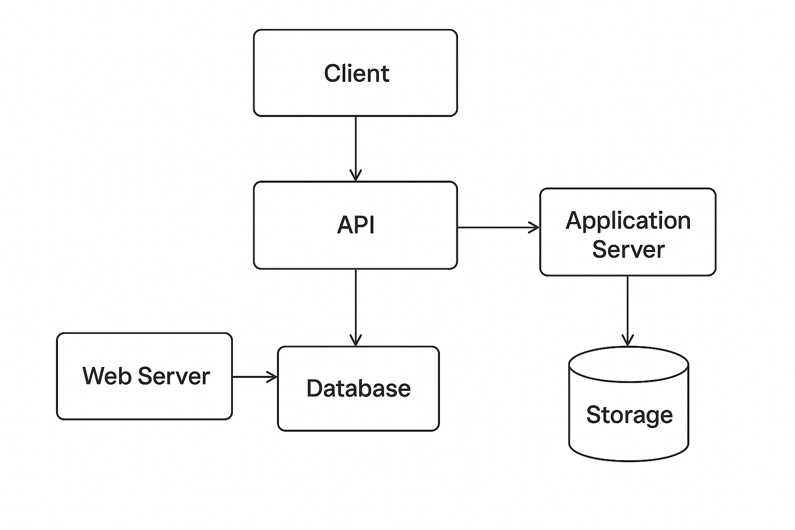

1.3 Technology Stack
Frontend:
- JavaScript, HTML, CSS
- Optionally React (or plain JS with modular structure)
- Responsive design to support different devices
Backend & ML:
- Python
  - Libraries: Pandas, Scikit-learn for data preprocessing and content-based recommendation
- Simple REST API server (e.g., Flask or FastAPI – one will be selected in implementation phase)
Database & Infrastructure:
- Firebase / Firestore for user data and ratings
- Open Library API and/or Kaggle “Book Recommendation Dataset” as primary data sources
- GitHub for version control and collaboration
2. Implementation Details
2.1 Codebase Structure
Planned high-level folder structure:
bookmind/
README.md
docs/
design_document.md
qa_plan.md
srs.md
pmp.md
frontend/
src/
components/
pages/
services/
public/
package.json
backend/
app/
api/
auth.py
books.py
recommendations.py
core/
config.py
models/
user.py
book.py
rating.py
ml/
recommender.py
preprocessing.py
requirements.txt
data/
raw/
processed/
notebooks/ # optional for experimentation
- frontend/ holds all UI-related files.
- backend/ contains API endpoints, business logic, and ML integration.
- data/ stores dataset files and preprocessing artifacts.
- docs/ includes all documentation required for the course and PA2.
2.2 Key Implementations
2.2.1 Authentication & User Management
- Module: backend/app/api/auth.py
- Responsibilities:
  - User registration (email, password, basic profile info)
  - User login (authentication & token/session generation)
  - Integration with Firebase Authentication or a custom auth mechanism
2.2.2 Book Management
- Module: backend/app/api/books.py and backend/app/models/book.py
- Responsibilities:
  - Fetching book information from Firestore and/or external APIs
  - Caching book metadata to reduce API calls
  - Providing endpoints for listing, searching, and filtering books
2.2.3 Rating & Review Handling
- Module: backend/app/api/books.py and backend/app/models/rating.py
- Responsibilities:
  - Storing user ratings and optional written reviews
  - Updating aggregated statistics (average rating, rating count)
  - Supplying rating data to the recommendation engine
2.2.4 Recommendation Engine
- Module: backend/app/ml/recommender.py
- Approach: Content-based filtering
  - Uses features like genres, authors, and text-based embeddings (e.g., TF-IDF on description or tags)
  - For a given user, the engine looks at rated books and computes similarity to other books in the dataset.
- Main tasks:
  - Preprocess book metadata into feature vectors (in preprocessing.py).
  - Compute similarity scores between books.
  - For each user, aggregate preferences and return top-N recommendations.
2.3 Component Interfaces
Not: Bunlar gerçek kod değil, tasarımda kullanmak için “signature” seviyesinde.
2.3.1 Backend – Auth Interface (example)
# backend/app/api/auth.py

def register_user(email: str, password: str, display_name: str) -> dict:
"""
Registers a new user and returns user profile data.
"""

def login_user(email: str, password: str) -> dict:
"""
Authenticates user and returns auth token or session info.
"""
2.3.2 Backend – Book & Rating API
# backend/app/api/books.py

def search_books(query: str, author: str | None = None, genre: str | None = None) -> list[dict]:
"""
Returns a list of books matching the query and optional filters.
"""

def rate_book(user_id: str, book_id: str, rating: float, review: str | None = None) -> dict:
"""
Stores a rating (and optional review) for a specific book by a user.
"""

def get_user_ratings(user_id: str) -> list[dict]:
"""
Returns all ratings submitted by the specified user.
"""
2.3.3 Backend – Recommendation Interface
# backend/app/ml/recommender.py

def get_recommendations_for_user(user_id: str, top_n: int = 10) -> list[dict]:
"""
Generates personalized book recommendations for the given user.
"""

def get_similar_books(book_id: str, top_n: int = 10) -> list[dict]:
"""
Returns books similar to a given book based on content features.
"""
2.3.4 REST API Endpoints (Example)
- POST /api/auth/register
- POST /api/auth/login
- GET /api/books/search?query=...&author=...&genre=...
- POST /api/books/{book_id}/rate
- GET /api/users/{user_id}/recommendations

2.3.5 API Endpoint Table
Endpoint | Method | Auth Required | Input Parameters | Request Body | Output | Description
/api/auth/register | POST | No | — | { email, password, display_name } | { user_id, email, display_name } | Creates a new user account.
/api/auth/login | POST | No | — | { email, password } | { token, user_id } | Authenticates user and returns session token.
/api/books/search | GET | No | query, author, genre | — | [{ book_id, title, author, genre, cover }] | Searches books by title/author/genre.
/api/books/{book_id}/rate | POST | Yes | book_id (path param) | { user_id, rating, review } | { success: true } | Stores a rating + optional review for a book.
/api/users/{user_id}/ratings | GET | Yes | user_id (path param) | — | [{ book_id, rating, review, timestamp }] | Returns user’s past ratings.
/api/users/{user_id}/recommendations | GET | Yes | user_id (path param) | — | [{ book_id, score, title, author }] | Returns personalized recommendations.
/api/books/{book_id}/similar | GET | No | book_id (path param) | — | [{ similar_book_id, score, title, author }] | Returns similar books using content features.
/api/books/{book_id} | GET | No | book_id | — | { title, author, genre, desc, cover } | Returns detailed book info.

2.4 Visual Interfaces
Planlanan ana ekranlar:
- Login / Register Page
  - Input fields: Email, Password, Confirm Password (for register), Display Name
  - Buttons: “Login”, “Create Account”
  - Simple error messages (e.g., invalid credentials, required fields)
- Home / Recommendations Dashboard
  - Top section: “Recommended for You” list (cover image, title, author, rating)
  - Side panel: Filters (genre, author)
  - Option to view “Top Rated” or “Recently Added” books
- Book Detail Page
  - Book cover, title, author, genres, short description
  - User rating widget (e.g., 1–5 stars) and text box for review
  - Button: “See similar books” → uses get_similar_books
- Search Results Page
  - Search bar (title/author/genre)
  - List of matching books with quick “Rate” or “Add to List” options
- User Profile Page
  - Shows user information (display name, email)
  - Lists user’s past ratings and reviews
  - Option to edit profile or delete account (linked to FR-9 in SRS)

3. Use Case Support in Design
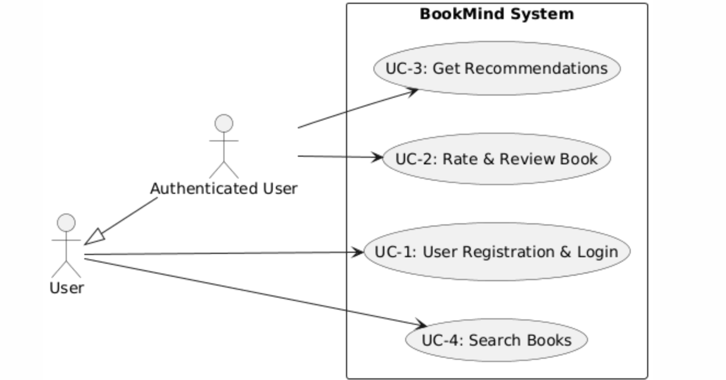
3.1 Selected Use Cases
- UC-1: User Registration & Login
  - Related FRs: FR-1
- UC-2: Book Rating & Review Submission
  - Related FRs: FR-2, FR-6
- UC-3: Recommendation Generation
  - Related FRs: FR-3, FR-5, FR-8, FR-10
- UC-4: Book Search by Title/Author/Genre
  - Related FRs: FR-7
3.2 UC-1 – User Registration & Login
Goal: Allow users to securely create an account and access the system.
Actors: User (Reader)
Related Functional Requirements:
- FR-1: The system shall allow users to register and log in securely.
Main Flow:
- User opens the web application and navigates to the login/register page.
- User enters email, password, and optional display name.
- Frontend sends a POST /api/auth/register request to the backend.
- Backend validates input and creates a new user in Firestore (or via Firebase Auth).
- For login, user submits credentials to POST /api/auth/login.
- Backend verifies credentials and returns an auth token or session info.
- Frontend stores auth state and redirects the user to the home/recommendations page.
Design Support:
- Presentation layer provides forms and validation.
- Service layer (auth module) interacts with the database and handles password hashing / token generation.
- Data layer persists user data and supports lookup.

3.3 UC-2 – Book Rating & Review
Goal: Enable users to rate and optionally review books.
Actors: Authenticated User
Related Functional Requirements:
- FR-2: The system shall allow users to rate and review books.
- FR-6: The system shall store all user data and ratings in a secure cloud database.
Main Flow:
- Authenticated user opens a book detail page.
- User selects a rating (e.g., 1 to 5 stars) and optionally enters text for a review.
- Frontend sends a POST /api/books/{book_id}/rate request with user_id, rating, and review.
- Backend validates input and stores it in the ratings collection/table.
- Backend may update aggregated book rating information.
- Frontend shows confirmation and updates UI.
Design Support:
- Rating model in backend stores (user_id, book_id, rating, review, timestamp).
- Recommendation engine periodically or on-demand uses rating data to refine user profiles.
- UI ensures rating widget and review text area are easy to use.

3.4 UC-3 – Recommendation Generation
Goal: Provide personalized book recommendations to the user.
Actors: Authenticated User
Related Functional Requirements:
- FR-3: The system shall generate book recommendations based on user ratings and preferences.
- FR-5: The system shall display top recommended books on the homepage.
- FR-8: The system shall filter recommendations by genre and author similarity.
- FR-10: The system shall collect feedback to improve future recommendations.
Main Flow:
- Authenticated user navigates to the home/recommendations page.
- Frontend calls GET /api/users/{user_id}/recommendations.
- Backend retrieves the user’s past ratings and preferred genres from the database.
- Recommendation engine computes a profile vector for the user and finds similar books using content-based similarity (e.g., cosine similarity on TF-IDF feature vectors).
- Recommendations are filtered by selected genre/author filters (if provided).
- Backend returns a list of recommended books ranked by relevance.
- Frontend displays books in a recommendation list with covers and key info.
- User feedback (clicks, new ratings) further refines recommendations over time.
Design Support:
- recommender.py encapsulates the ML logic.
- Backend API abstracts recommendation generation behind a simple endpoint.
- Data layer stores both book features and user ratings.
- Frontend supports filtering options (genre, author).
3.5 UC-4 – Book Search
Goal: Allow users to search books by title, author, or genre.
Actors: Any User (guest or authenticated)
Related Functional Requirements:
- FR-7: The system shall allow users to search for books by title, author, or genre.
Main Flow:
- User enters a search text (e.g., “Dostoyevsky”) and optionally selects filters (genre, min rating).
- Frontend sends a GET /api/books/search?query=...&author=...&genre=....
- Backend searches the database (and optionally external API) for matches.
- Backend returns a list of books that satisfy the query and filters.
- Frontend displays the results with pagination or infinite scroll.
Design Support:
- BookService in the backend encapsulates search logic and DB queries.
- Indices (title, author, genre) in the database improve search performance.
- UI provides a simple search bar + filter panel.
4. Design Decisions
4.1 Architecture Choices
- Layered Architecture was chosen instead of microservices due to:
  - Small team size and limited project time (one semester).
  - Lower overhead in deployment and maintenance.
  - Easier debugging and integration for a student project.
4.2 Technology Comparisons
4.2.1 Database: Firestore vs Relational Database (e.g., PostgreSQL)
- Firestore (Chosen):
  - Pros:
    - Easy integration with Firebase Auth.
    - Serverless, scales automatically.
    - JSON-like structure fits book and rating documents.

  - Cons:
    - Less suited for complex joins.
- Relational DB (Alternative):
  - Pros: Strong consistency and structured relationships.
  - Cons: Additional setup, hosting, and ORM configuration needed.
Decision: Firestore is chosen due to simplicity, lower DevOps overhead, and good fit for project scale.
4.2.2 Frontend: React vs Vanilla JS
- React (Preferred Option):
  - Pros: Component-based structure, state management, easier to scale UI.
  - Cons: Requires extra tooling (Node, bundlers) and learning curve.
- Vanilla JS + Modular Structure (Alternative / Backup):
  - Pros: Simpler initial setup, fewer dependencies.
  - Cons: Harder to maintain for complex stateful UI.
Decision: React is preferred; if time constraints become critical, the project can fall back to a simpler modular JS structure without changing the backend.
4.2.3 Recommendation Approach: Content-Based vs Collaborative Filtering
- Content-Based (Chosen):
  - Pros: Works even with fewer users, relies on book metadata; suitable when user-user rating matrix is sparse.
  - Cons: Recommendations may be narrower (similar items only).
- Collaborative Filtering (Alternative):
  - Pros: Can capture more diverse preferences based on other users.
  - Cons: Requires larger and denser rating data; more complex to implement.
Decision: Content-based filtering is chosen for initial implementation due to dataset constraints and limited development time.
4.3 Rationale for Final Choices
All selected technologies and architectural decisions aim to:
- Minimize setup and infrastructure costs.
- Align with course expectations (Python + ML, web-based UI, GitHub workflow).
- Ensure that the four selected use cases can be implemented and demonstrated within the semester.
5. GitHub Commit Requirement
5.1 Repository Structure and Branching
- Main repository: github.com/<organization-or-user>/bookmind
- Branches:
  - main: Stable, reviewed code.
  - develop: Integration branch.
  - Feature branches: feature/frontend-ui, feature/recommender, feature/auth, etc.
5.2 Commit Message Conventions
Use short, descriptive commit messages following this style:
- feat: add login page UI
- feat: implement content-based recommender
- fix: handle empty search results
- docs: update design document use case mapping
Each commit should focus on a small, coherent change and mention the related module or document.

5.3 Traceability Between Code and Design
- Design document and QA plan are stored under docs/.
- When implementing a use case:
  - Reference it in the commit message, e.g., feat: implement UC-2 rating endpoint.
- Interface changes in backend/frontend must be reflected in this document where necessary (e.g., API signatures).

6. Task Matrix (Design Document)
Section | Task Description | Responsible Member
Contributors & Front Page | Listing team members and general info | All Members
1. System Overview | Project description, architecture, tech stack | İclal Suzan
2. Implementation Details | Code structure, key modules, interfaces, visual interfaces | Melih Rıza Koç
3. Use Case Support in Design | Use case descriptions, FR mapping, flows | İclal Suzan, Samet Emre Demir
4. Design Decisions | Technology comparisons and justification | Melih Rıza Koç
5. GitHub Commit Requirement | Repo strategy, commit conventions, traceability | Samet Emre Demir
Document Integration & Final Review | Consistency check, formatting, final edits | All Members

